**

***Database Project Report***

***BLOOD DONATION WEBSITE***

December 19, 2021

**

*Miss Anum Qureshi*

*HADIQA KHAN 19K-0121 (Group Leader)*

*SHARJEEL KHAN 19K-1287*

*NOOR US SAHAR 19K-0224*

*Table of Contents*

**1.** **Problem Statement** 2

1.1. Project Background 2

1.2. Project Scope 2

1.3. Not in Scope 2

1.4. Project Objectives 2

**2.** **ERD** 3

**3.** **Description:** 4

3.1. Donor Perspective: 4

3.2. Acceptor Perspective: 5

**4.** **Features:** 5

## **Problem Statement**

#### 1.1. Project Background

*The majority of individuals are in need of web-based blood donation. Patients need to get blood to inhabit crisis time. At present individuals are had to realize how to contact blood contributors on the web. This website gives how to get blood at their genuine chance to be longer life time.*

#### 1.2. Project Scope

#### This Project will get the information of Donor, and the blood that will be donated by that donor; and store that in database. Another user that is Acceptor will find the donor for the blood according to its requirement from its respective location (using area and blood centers).

#### 1.3. Not in Scope

*It will not manage the inventory of blood, because till now there is no admin module in our project.*

#### 1.4. Project Objectives

*The majority of individuals are in need of web-based blood donation. Patients need to get blood to inhabit crisis time. At present individuals are had to realize how to contact blood contributors on the web. This website gives how to get blood at their genuine chance to be longer life time. Data about benefactors and patients will be store in database with the goal that it is prepared to give blood immediately. The core objective of this web application is to provide the opportunities to get Blood, Platelets and Plasma as soon as possible at nearby locations*.

## **ERD**

Donor Registration

Donates

Blood

Donation

gives

Disease

has

Accepts

Acceptor

Stores at

Location

## **Normalized Schema**

|  |  |  |  |  |  |  |  |  |  |  |
| --- | --- | --- | --- | --- | --- | --- | --- | --- | --- | --- |
| First Name | Last  Name | Donor_id | Gender | Age | Contact | Blood_group | Blood_sign | Email | Password | Date |

Donor_Registration

Donation

|  |  |  |  |  |  |  |
| --- | --- | --- | --- | --- | --- | --- |
| Donation_id | Donor_id | Date_of_donation | Availability | Location_id | Disease | Weight |

Blood

|  |  |  |  |  |  |  |
| --- | --- | --- | --- | --- | --- | --- |
| Donation_id | Density | Hemoglobin | Ph_value | Iron | Wbc | Rbc |

Disease

|  |  |  |  |  |  |  |
| --- | --- | --- | --- | --- | --- | --- |
| Donation_id | BP | Anemia | Diabetes | Chainsmoker | HIV | Allergies |

|  |  |  |  |  |  |  |  |
| --- | --- | --- | --- | --- | --- | --- | --- |
| Loc_id | B_name | Hosp/BloodC | Address | Contact | Email | Contact_person | Area |

Location

Acceptor

|  |  |  |  |  |  |  |
| --- | --- | --- | --- | --- | --- | --- |
| Acc_id | FirstName | LastName | Contact | Near_address | Blood_group | Blood_sign |

## **Relational Data Model**

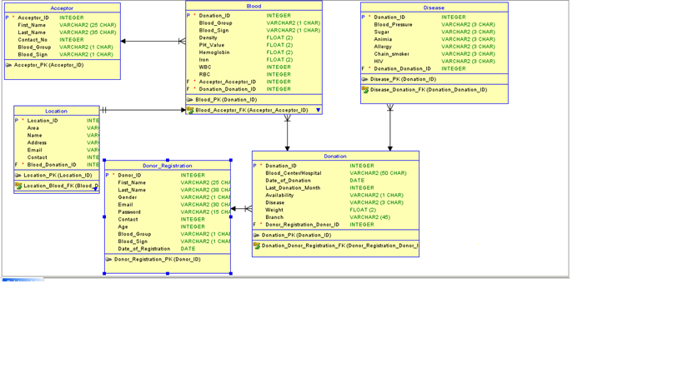

## **Description:**

#### Donor Perspective:

*Donor have two options:*

*First is registration if he/she is not registered so they can register themselves by filling the form in the registration interface.*

*Second option is login, user can login by entering email and password, the database and backend collectively verify the email and password, then allow to navigate to other interface, then after verification, user have 4 options.*

1. *Donor Info: It shows the user’s profile.*
2. *Donation Info: In this the user have two options: 1. show available donations then our website will allow it to delete the donation due to any circumstances. 2. Show non available donations that has been accepted by the acceptor.*
3. *Donate Blood: In this interface the user will donate the blood by entering the information of its own, if have any disease and at last the information of blood*

#### Acceptor Perspective:

*Acceptor will click on find donor, new interface will be opened, then he/she will select the area, blood group and blood sign then the details of the donor of that perspective area, blood group and blood sign. Then user will select one donor at a time. After selecting new interface will open and acceptor will enter its own information that will be stored in the database.*

## **Features:**

*The features of project can be shown through the following video link:*

[*https://drive.google.com/file/d/1LDlB10kS87JMh3hegiXO1LkSkEePzyO1/view?usp=sharing*](https://drive.google.com/file/d/1LDlB10kS87JMh3hegiXO1LkSkEePzyO1/view?usp=sharing)